Final Project

Balraj

**Project Proposal**

## Client Review Form

My developer’s name: **Balraj Singh**

This form is intended to let you review the communication skills of your developer for this assignment. Your review will partly count towards their final mark. Do not take into account technical skills.

Grading scale

You must grade your developer for each item listed in the tables below. 1 being the lowest, 5 the highest.

|  |  |  |  |  |
| --- | --- | --- | --- | --- |
| **1** | **2** | **3** | **4** | **5** |
| Strongly disagree | Disagree | Ok | Agree | **Strongly agree** |

Review your developer

|  |  |  |
| --- | --- | --- |
| Item | Grade | Comment |
| Communicated clearly and effectively | A | Communicate on time and on call |
| Kept you informed of the progress | A++ |  |
| Met timelines | A |  |
| Responded promptly to problems | B++ |  |
| Met overall project objectives | A |  |
| Was open to new ideas and suggestions | A |  |
| Was easy to work with | A | Yes, It is very easy to work |

## Comments

Provide any extra comments on your developer’s communication skills and professionalism.

He is very good and fulfil all the requirements

**Signed by Client**

|  |  |
| --- | --- |
| **Signature: Sehajdeep kaur** | **Date: 17/11/2021** |
| **Name: Sehaj deep** | **Title: Final Project** |
| **Contact details (email/Tel):** **Sehajdeep456@gmail.com** | |

Client Details

|  |  |
| --- | --- |
| Client Name | Sehajdeep Kaur |
| Project Name | EMDA |
| Email | Sehajdeep456@gmail.com |
| Phone | 028765437 |
| Expected Date | 17 nov 2021 |

Project Introduction

With the help of MVC, I create web application on EMDA. Firstly, user must see frontend of this website, to sign in as a staff . They can work with CRUD operations. The name of the project is EMDAAdvanced. The main purpose of the application is help staff to clock in clock out. To sign out staff must give a reason. staff can edit their first name and last name but they can’t delete their information. New staff can enter and staff can also request for annual leave. User can register as a new user.

Target Audience

The target of the audience is to clock in and clock and out as a staff. If this website get chance to interact in market this will be suitable for the target audience and fulfil its main purpose.

Review and Colour Scheme

I am Sehajdeep kaur as a client review the mock-up design, wireframes of initial design of my project. I really like this concept. I would like to proceed further.

I suggest something about colour combination in this project to my developer.

I like Blue and white combination in header and footer and choose any colour in middle.

Wireframes

Project Deliverables

The Project deliverables are:

Final Report: This will be the final report of this project.

Coding: The code of the project will go under this.

Testing: All testing details will covered in this project.

Resource Requirements

* Asp.net MVC Framework
* Identity framework- ASP

Pages

There will be four pages in application Home, staff, Reason and Annual leave. Pages must be in navigation bar.

Final Project

Home page

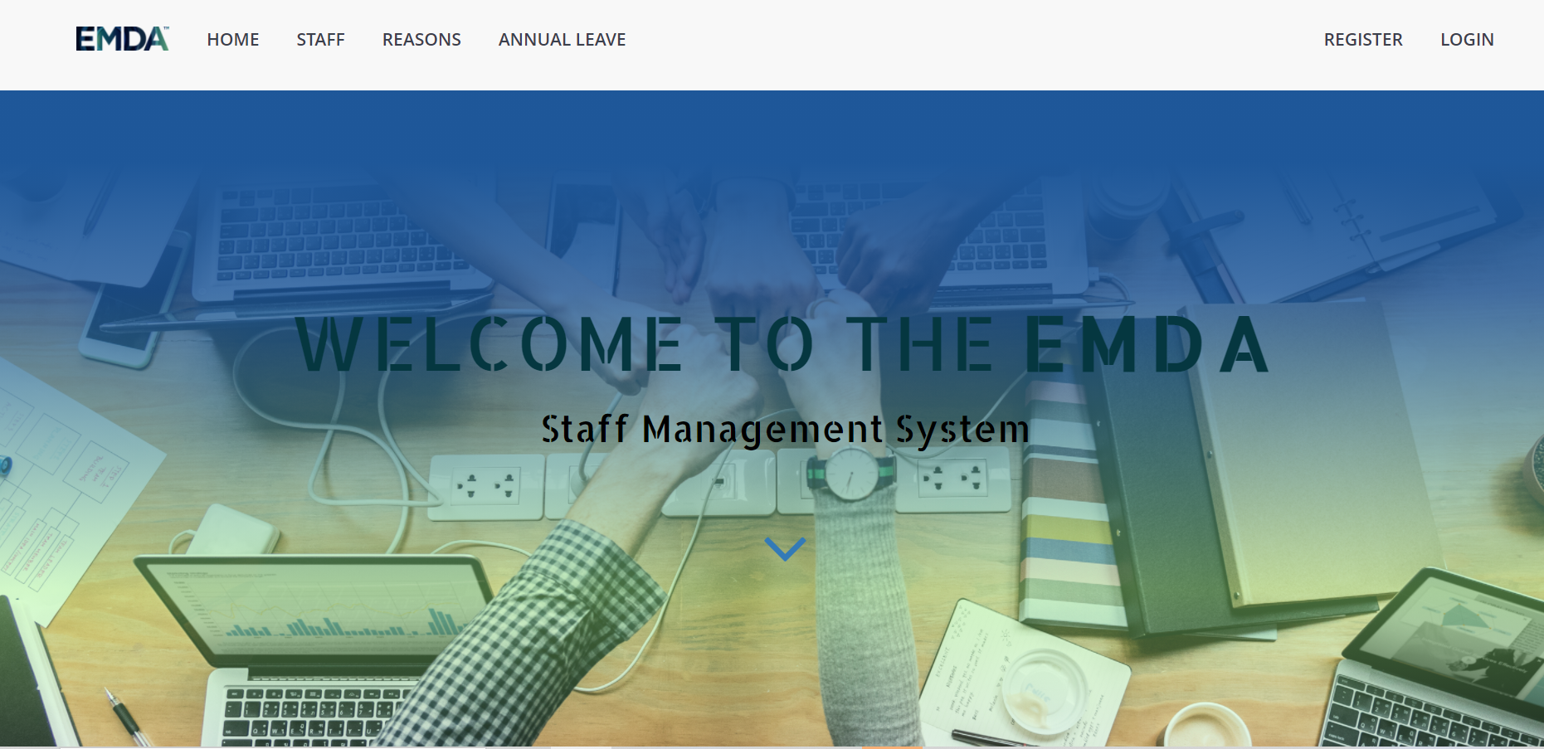

Staff Page

Annual Page

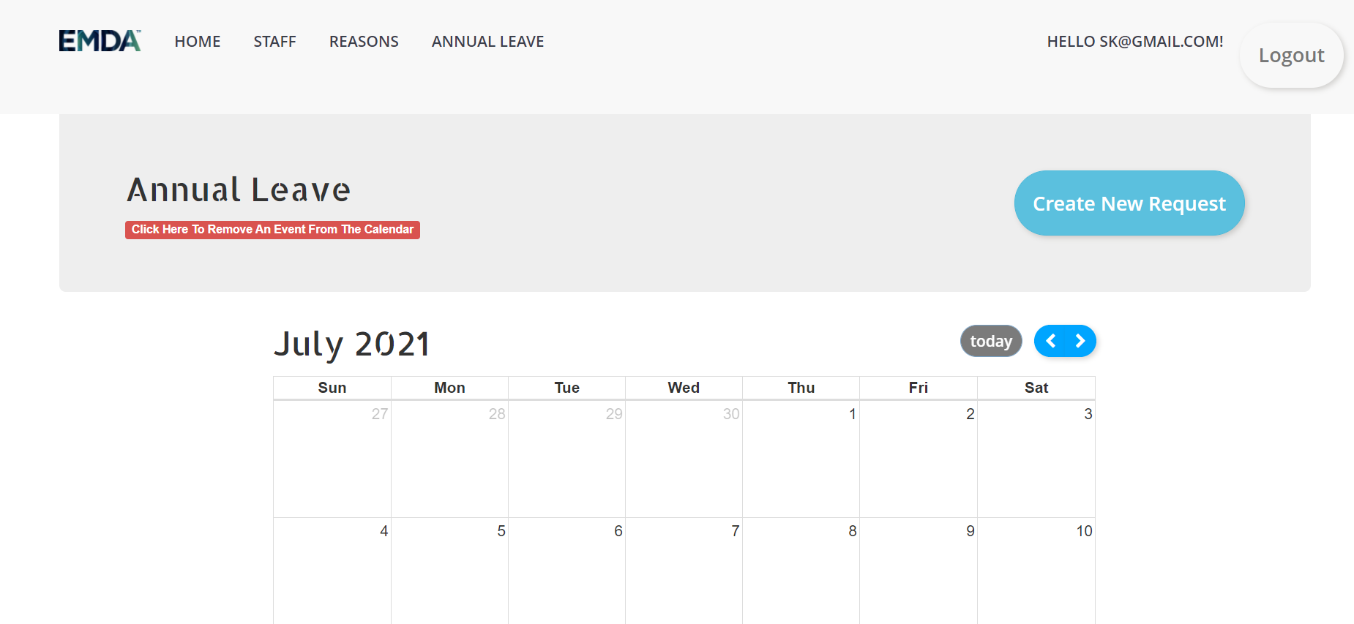

Login Page

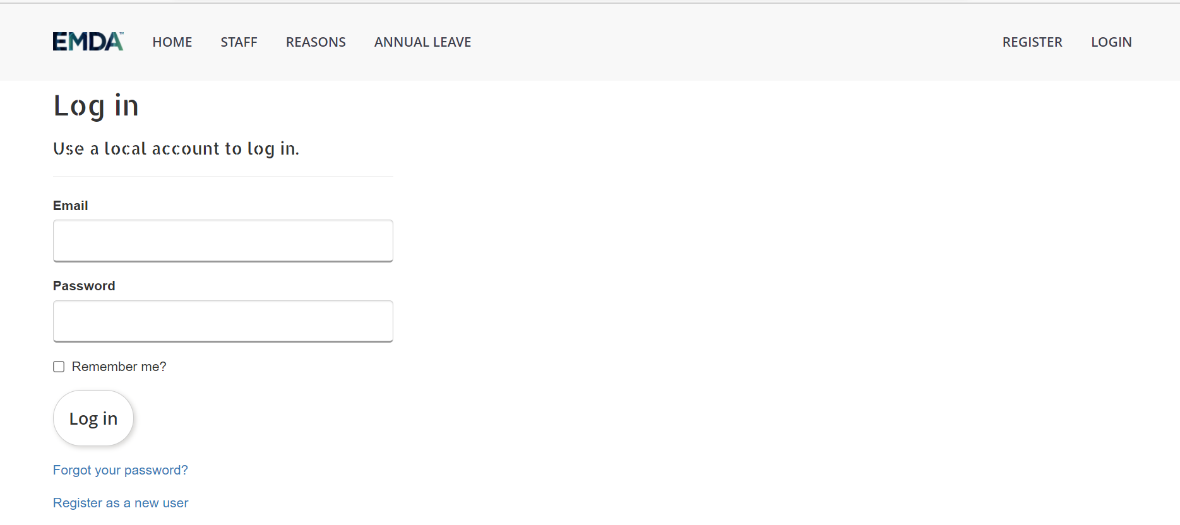

Register Page

Goals:

The main goal of this project is to implement an online web application using Asp.Net. The name of this web application will be “EMDAAdvanced” . User can manage staff by adding, editing, and checking details.

User Access Levels

Only register user can access the features of this application.

Summary

This app will be useful to calculating the employee’s hours.

**Software Development Life Cycle**

Planning

Planning of the project is done in word file [Planning, Cost , Testing.xlsx](Planning,%20Cost%20,%20Testing.xlsx)

Where I mention about how I plan, read requirements, Choose platform , And start work With Planning.

Analysis

After done planning, I research about topic, problems and risks . Make project proposal.

Design

Firstly, Start with Wireframes. I make wireframes related to my expected design. After client confirmation I start implementation and here client give me detail about colour scheme. [Mockup Designs](Mockup%20Designs)

Implementation

After the Mockup designs , I implement everything according to my initial planning. Using code first technique I make MVC project according to client requirement.

[..\ProjectFinalEMDAAdvanced.sln](../ProjectFinalEMDAAdvanced.sln) You can go to this link and check code performance.

Testing

[Planning, Cost , Testing.xlsx](Planning,%20Cost%20,%20Testing.xlsx)